 NHSGG&C Prescribing Advice:
Long-acting β₂ Agonist (LABA) and Long-acting Muscarinic Antagonist (LAMA) Inhalers for the Management of Chronic Obstructive Pulmonary Disease (COPD) in Primary Care

To be used by primary care prescribers involved in the care and review of patients with COPD
For use in conjunction with NHSGG&C Primary Care COPD Guidelines and Inhaler Device Guides
GGC Formulary Prescribing Resources: http://www.ggcprescribing.org.uk/prescribing-resources/

There have been a number of combination LABA/LAMA inhalers enter the market during 2014 and 2015. The purpose of this guidance is to summarise the place in therapy for single LABA and LAMA inhalers and combination LABA/LAMA inhalers in the management of COPD.

Individual LABA and LAMA inhalers
Individual LABA or LAMA inhalers are recommended for a trial in patients with COPD at step two of the NHSGG&C COPD guidelines after a trial of the short-acting β₂ agonist, salbutamol (preferred choices: metered dose inhaler (MDI), Easyhaler® or Easi-Breathe®).
- Formoterol is the NHSGG&C first choice long-acting β₂ agonist (LABA): 12micrograms twice daily
  - Easyhaler® formoterol 12micrograms is a dry powder inhaler (DPI) and is the first choice LABA device
  - Atimos® (formoterol) 12 micrograms Modulite® is a MDI and the second choice LABA device
  - Other LABA inhalers included on the NHSGG&C formulary (but not preferred choices): Foradil® (formoterol) 12micrograms MDI, Neovent® (salmeterol) 25micrograms MDI, Oxis® (formoterol) 12micrograms Turbohaler, Serevent® (salmeterol) 25micrograms Evohaler (MDI) and 50micrograms Accuhaler® and Striverdi® (olodaterol) 2.5micrograms Respimat
  - LABA inhalers not currently included on NHSGG&C formulary: Onbrez® (indacaterol) Breezhaler 150 and 300microgram
- Spiriva® (tiotropium) 18micrograms Handihaler is the NHSGG&C first choice long-acting muscarinic antagonist (LAMA)
  - Eklira® (aclidinium) 322micrograms Genuair  is the second choice LAMA
  - Other LAMA inhalers included on the NHSGG&C formulary (but not preferred choices): Incruse® (umeclidinium) 55micrograms Ellipta  and Spiriva® (tiotropium) 2.5micrograms Respimat
  - LAMA inhaler not included on NHSGG&C formulary: Seebri® (glycopyrronium) 44micrograms Breezhaler 
Spiriva® (tiotropium) 2.5micrograms Respimat is now licensed as an add-on maintenance bronchodilator in adult patients with asthma who are at Step 4 of the asthma guidelines with poorly controlled asthma (at least one course of oral prednisolone for a severe exacerbation in the last year) and have persistent airflow limitation (post bronchodilator FEV1 < 80% of predicted). For specialist initiation only.

Combination LABA/LAMA inhalers
Combination LABA/LAMA inhalers are recommended in patients with COPD at Step 3 who have had a partial response to a single LABA or LAMA but remain symptomatic. The Step 2 LABA or LAMA should be stopped and replaced with LABA/LAMA combination inhaler.
- Duaklir® (aclidinium and formoterol) 340/12micrograms Genuair  is a DPI and the LABA/LAMA combination inhaler of choice
- The other LABA/LAMA combination inhalers on the NHSGG&C formulary (but not preferred choice) are the DPI, Anoro® (umeclidinium and vilanterol) 55/22microgram Ellipta  and Spiolto® (tiotropium and olodaterol) 2.5micrograms/2.5micrograms Respimat  Page 1 of 2

Pictures and doses of all LABA and LAMA inhalers on NHSGG&C Formulary Preferred List:

LABA inhalers of choice:

FIRST CHOICE: Easyhaler® Formoterol 12micrograms, ONE puff TWICE daily
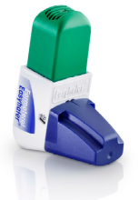
SECOND CHOICE: Atimos® (formoterol) Modulite MDI 12micrograms, ONE puff TWICE daily
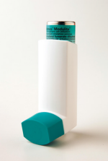

___________________________________________________________________________________________________________________
LAMA inhalers of choice:

FIRST CHOICE: Spiriva® (tiotropium) Handihaler, 18microgram, ONE dose ONCE daily
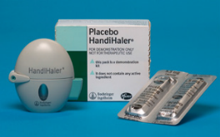

SECOND CHOICE: Eklira® (aclidinium) Genuair  322micrograms, ONE puff TWICE daily
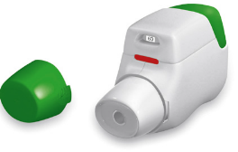
______________________________________________________________________________________________________________________
LABA/LAMA combination inhaler of choice:

Duaklir® (aclidinium and formoterol) Genuair  340/12microgram, ONE puff TWICE daily

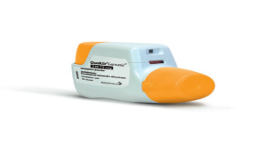

To prevent confusion, all inhalers should be prescribed by brand name, with the exception of salbutamol MDI
= black triangle medicine, subject to additional monitoring by the European Medicines Agency
South Prescribing Team, 18th January 2016
Page 2 of 2

