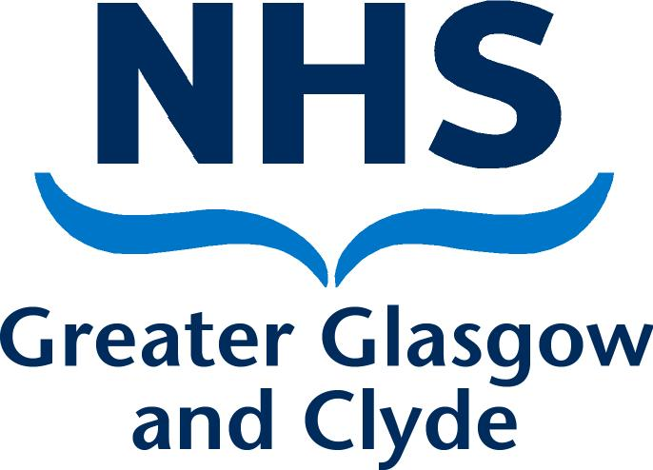DISULFIRAM – UPDATED GUIDANCE DURING SHORTAGE
7th July 2017

Clinical Indication: Adjunct in the treatment of Chronic Alcohol Dependence

Introduction

There is a current shortage of UK licensed Disulfiram 200mg tablets. This is the fourth time there has been a national shortage since 2008. Teva® has recently acquisitioned generic disulfiram from Actavis and has supplied minimal information relating to the cause of the shortage. Stocks are not expected until mid September 2017.

Greater Glasgow and Clyde Health Board have patients being prescribed Disulfiram in both primary and secondary care, with patients receiving supplies at varying intervals from community pharmacies, inpatient wards and day units. Disulfiram is prescribed by doctors specialising in Addiction (as per formulary), although we are also aware of prescribing by G.Ps.

As there is no UK licensed alternative this guidance aims to provide information to ensure that patients can continue to receive Disulfiram during the shortage.

Advice for Prescribers

Please contact the patient’s pharmacy prior to writing a prescription, some pharmacies have

-licensed stock

-zero stock and therefore will need to order an available unlicensed product

Stocks are currently fast moving as all Health Boards are accessing these.

Alternative Source of Disulfiram
Product | Stock Status | Prescription Generation
Licensed 200mg stock  (from Teva) | Phoenix has a small amount of stock  (not all pharmacies use this wholesaler) | Via EMIS or VISION
Disulfiram 250mg tablets (Antabus) - unlicensed product from Spain | In stock with wholesaler (IDIS), available for next day delivery

A blanket unlicensed medicines form has been completed by the Associate Medical Director for the use of 250mg Disulfiram tablets (Antabus®), imported from Spain. (We also have the same for the 500mg Disulfiram tablets (Esperal®), imported from France).

Dosing varies across the Health Board. The table below shows some suggested doses for switching to an unlicensed product:
Current Disulfiram Dose | Suggested Unlicensed Dose
200mg (1 tab) daily | 250mg daily
400mg (2 tabs) Monday, Wednesday, Friday  Or  400mg (2 tabs) Monday, Wednesday and 600mg (3 tabs) Friday | 500mg (2 x 250mg) Monday, Wednesday, Friday
600mg (3 tabs) Tuesday and 800mg (4 tabs) Friday | 500mg (2 x 250mg) Tuesday and Friday

Please contact the patient’s pharmacy prior to generating the prescription.

Prescription Wording example for 250mg product (EMIS and Vision)

Disulfiram 250mg tablet (Antabus)
Send 24 tablets
Label two tabs Monday, Wednesday, Friday
Supply two tabs Monday, Wednesday, Friday
Breathalysed and supervised on day of collection

Generating a prescription:
Product | Script generation | PIL
250mg disulfiram tablets (Antabus) | EMIS prescription  (see below*). | Translated PIL not appropriate for use, instead use standard PIL from NHS 24:  http://www.choiceandmedication.org/nhs24/pdf/billdisulfiram.pdf

*The 250mg tablet has been added to EMIS and VISION prescribing systems. Prescriptions no longer have to be handwritten.

VISION Practices
Generic 250mg (and 500mg) disulfiram is contained on VISION. Unclick ‘FORMULARY’ and ‘ALL GENERICS’, then click ‘SPECIALS’ as below. As this is generic please add ‘Antabus’ (250mg) in the text section as per the example on the following page*.

EMIS Practices
Generic 250mg (and 500mg) disulfiram is now contained on EMIS. This is searched for by the usual process. As this is generic please add ‘Antabus’ (250mg) in the text section as per the example below*.
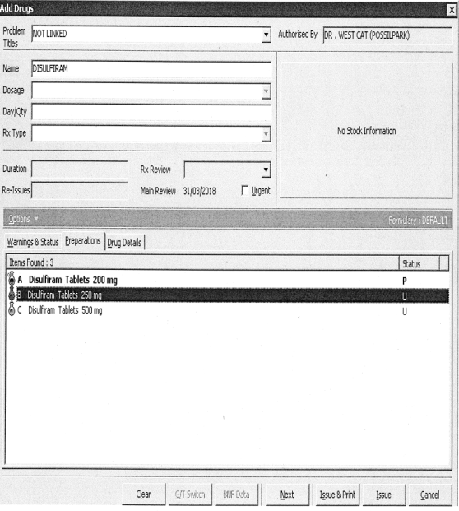
For both EMIS and VISION select the preparation, then expand further to say the brand (Antabus 250mg tabs or Esperal 500mg tabs), what dose and frequency the patient is to follow, along with the instalment (‘supply’) and ‘Breathalysed and supervised on day of collection’ if appropriate. If pharmacy supervision is arranged this should continue as previous. It is best to write the dispensing pharmacy in the top right hand corner.
*250mg example below (please see table on page 2 for other doses/frequencies):
Prep | Disulfiram 250mg tablet  24 tablets  Antabus 250mg tablets, two tabs Monday, Wednesday, Friday  two tabs Monday, Wednesday, Friday  Breathalysed and supervised on day of collection
Send
Label
Supply
Pharmacy Text

Day Units / Inpatient Addiction Wards

It may be necessary for patients attending Day Units for supervised disulfiram to remain there (rather than moving disulfiram supervision to a Community Pharmacy) during the shortage, depending on local stocks.

Doctors experienced in the treatment of Addiction are resident in these areas and are able to make the dose adjustments necessary for the use of the 250mg tablet if necessary.

Stock is ordered via the usual method.

All staff should be informed of the current situation, especially if both licensed and unlicensed stocks are stored on the ward. Steps should be taken to minimise the risk of medication errors i.e. preparations should be stored separately.

Kershaw and Eriskay Inpatient and Day Units should contact Diane Watson, Clinical Pharmacist, Addictions (Diane.Watson@ggc.scot.nhs.uk) with any queries.

Inpatient Wards

It is anticipated that fewer patients will fall into this category. Advice should be sought from your ward pharmacist or local dispensary about which product is available and advice on its use.

All staff should be informed of the current situation, especially if both licensed and unlicensed stocks are stored on the ward. Steps should be taken to minimise the risk of medication errors i.e. preparations should be stored separately.

Community Pharmacies

Community Pharmacies in GGC please follow the advice below:
- Contact sister/local stores to try and fulfil licensed prescription.
- If no licensed stock available contact IDIS to assess unlicensed stock availability (01932 824000)
- If 250mg stocks are available contact the prescriber with regard to requesting a change of prescription to the 250mg unlicensed tablet. If the prescriber does not feel this is within their competence, they should contact their local addiction team for advice.
- Order from IDIS on 01932 824000. Please note there is a minimum order charge of £30, currently Antabus (40 x 250mg tablets) is being charged at £56 (approximate charge). Orders placed before 5.30p.m. will be shipped that day and should be received within 1-2 working days. A standard lead time of 2-4 weeks will be quoted if no stock is available, if this occurs call Jennifer Torrens (number below).
- The Health Board will reimburse the cost of the drug and cost of delivery, although we ask that pharmacies order wisely to minimise extra costs to the Health Board. This is claimed via the usual route for a special and therefore authorisation should be sought (telephone 0141 232 1777).
- If pharmacy supervision is arranged this should continue as previous.

If a patient misses a few doses (not advised), please remind patients that the Disulfiram Ethanol Reaction may occur for up to 2 weeks following discontinuance of disulfiram, therefore patients should continue to expect a reaction to alcohol. For those pharmacies that are part of the supervised disulfiram initiative patients can continue to visit the pharmacy to be breathalysed during this period for continued support.

Additional information and updates on the current stock position will be provided when available.

Please contact Jennifer Torrens (07557012870) or other members of the Addiction Pharmacy Team on 0141 303 8931 if you require any further details or have any queries.

Further Information.
Guidance amended by
Jennifer Torrens, Alcohol Pharmacist, Addiction Services NHS GGC, 07557012870 Jennifer.Torrens@ggc.scot.nhs.uk

Guidance originally produced in 2008 by:
Dr Anupam Agnihotri, Consultant Psychiatrist, Southern General
Aileen Cedervall, Clinical Pharmacist, Addictions.
Carole Hunter, Lead Pharmacist, Addiction Services NHS GGC
Elaine Linderman, Medicines Information Pharmacist, Leverndale Hospital 0141 211 6478

